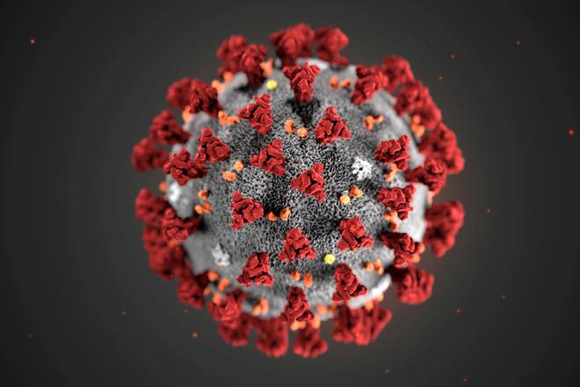 ***A STATISTICAL STUDY ON THE IMPACT OF COVID-19 ON HEALTH IN INDIA***

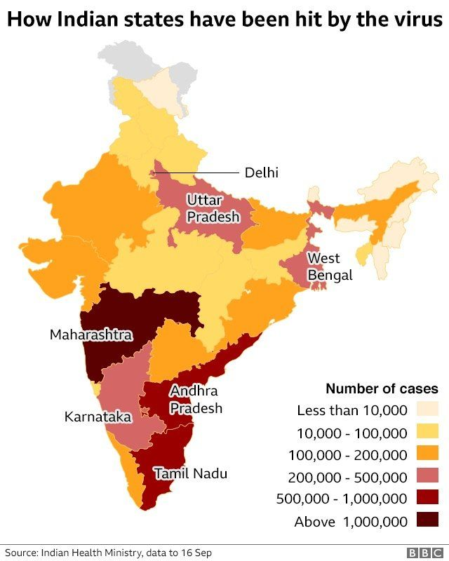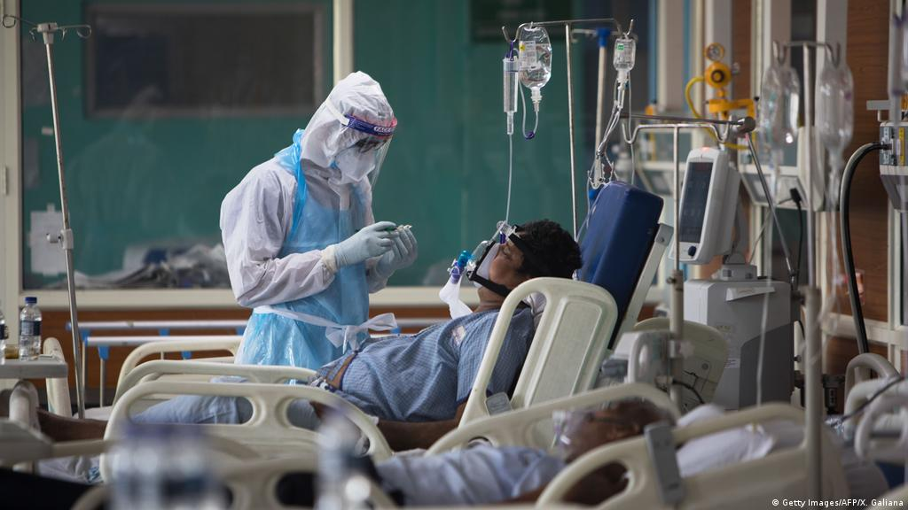

## The first reported case and the initial reaction to COVID-19

The first official cases of COVID-19 were recorded on the 31st of December, 2019, when the World Health Organization (WHO) was informed of cases of pneumonia in Wuhan, China, with no known cause. On the 7th of January, the Chinese authorities identified a novel coronavirus, temporally named 2019-nCoV, as the cause of these cases.

Weeks later, the WHO declared the rapidly spreading COVID-19 outbreak as a Public Health Emergency of International Concern on the 30th of January 2020. It wasn’t until the following month, however, on the 11th of February that the novel coronavirus got its official name - COVID-19. Nine days later, the US Centers for Disease Control and Prevention (CDC) confirmed the first person to die of COVID-19 in the country.

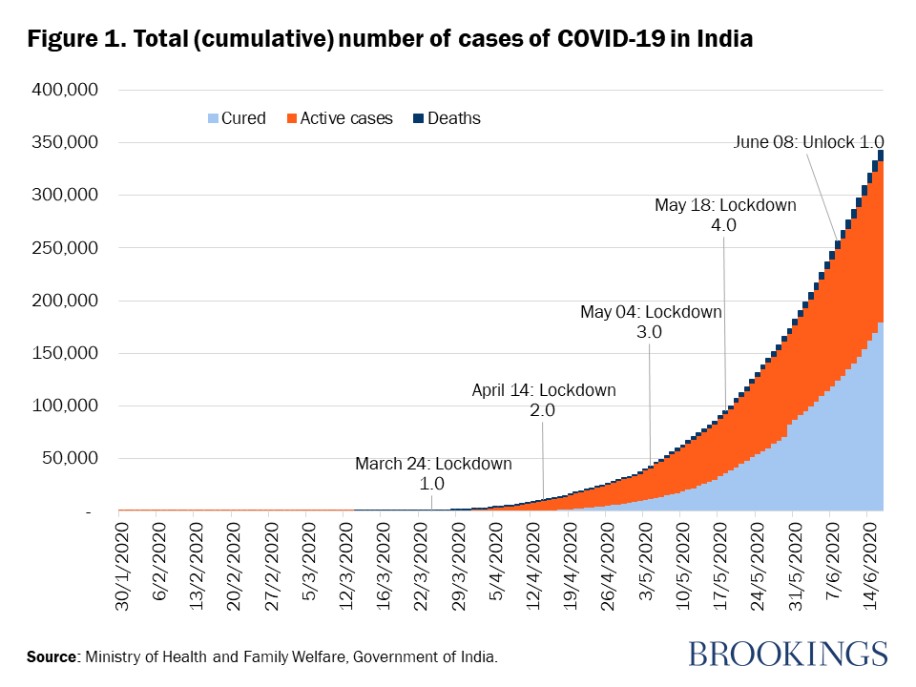Coronaviruses are a large family of viruses, including some that cause the common cold to some that cause major diseases such as the Severe Acute Respiratory Syndrome (SARS) and the Middle East Respiratory Syndrome (MERS).

**Crippling impact of pandemic on health system**

## Front line health workers facing stress, anxiety and burnout

As the State rides the third wave of COVID-19 and the focus shifts to how normal life can be resumed, the crippling impact the pandemic has left on the State’s health system is more stark than ever.

Two years of fighting SARS-CoV-2 has been catastrophic not just for the State’s health system, which expended all its energy on futile exercises to tie down the virus and lay claim to exceptionalism, but also the healthcare workers, most of whom are exhausted and suffering burnout.

The stigma surrounding COVID, anxiety over personal safety and that of families back home, physical rigours of operating donning a suffocating PPE kit and helplessness of having to watch people die every day were humbling and distressing, said doctors.

# Covid-19: India outrage over 'no oxygen shortage death data' claim

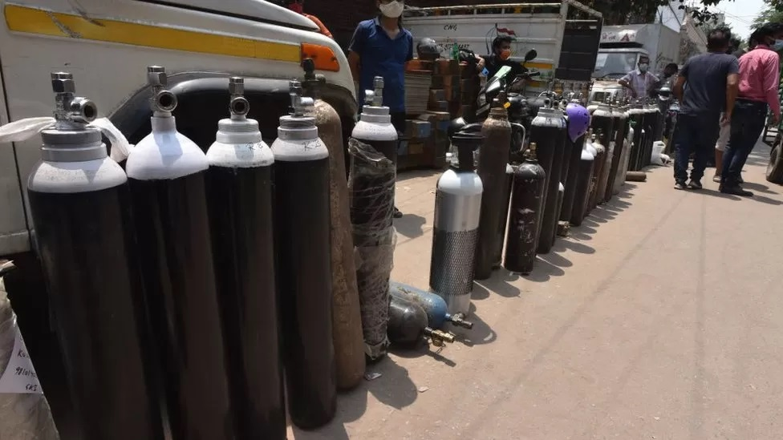

People are waiting for up to 12 hours to get a cylinder filled

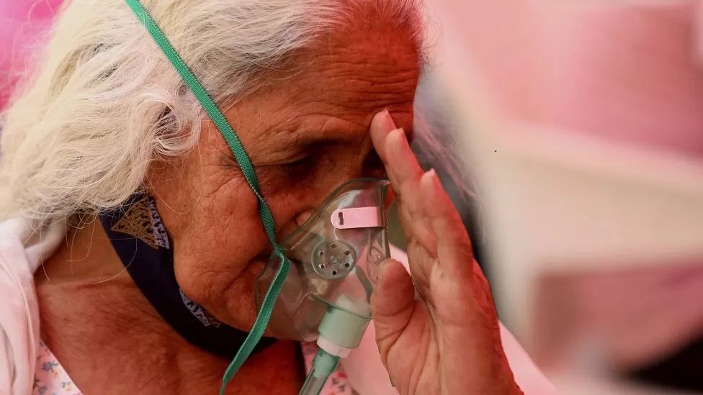

Corona virus: 'India's healthcare system failed my family'

**Indians have expressed shock and anger after a junior health minister told parliament that no Covid deaths had been reported due to oxygen shortages.**

Hospitals across the country ran out of oxygen in April and May during a deadly second wave - there were daily reports of people dying from a lack of oxygen.

But the government said on Tuesday that "no deaths due to lack of oxygen has been specifically reported by states. India has reported more than 418,000 Covid deaths so far. And more than half of those happened after 16 April when Covid cases began to climb sharply.

Dr Gautam Singh, who runs a 50-bed hospital in Delhi, told the BBC that there was an acute shortage of oxygen in April and May. "We were managing oxygen on an hourly basis. We came so close to losing patients. Somehow we begged and borrowed to save our patients. But I do know other hospitals that lost patients due to the shortage."

India's health infrastructure began to crumble as the demand for hospital beds, oxygen and medicines soared. Social media was flooded with desperate pleas for help from both families and doctors as patients gasped for breath. The trauma was on vivid display day after day and made global headlines.

So, the government's statement that it had no data on oxygen deaths has angered and shocked Indians.

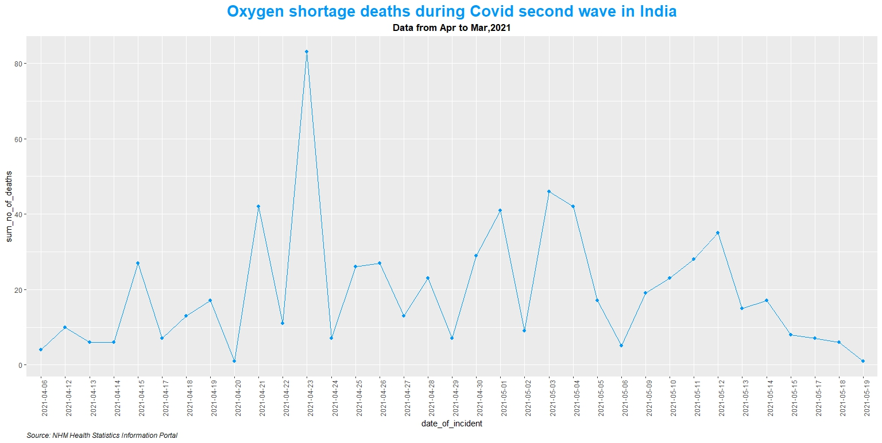

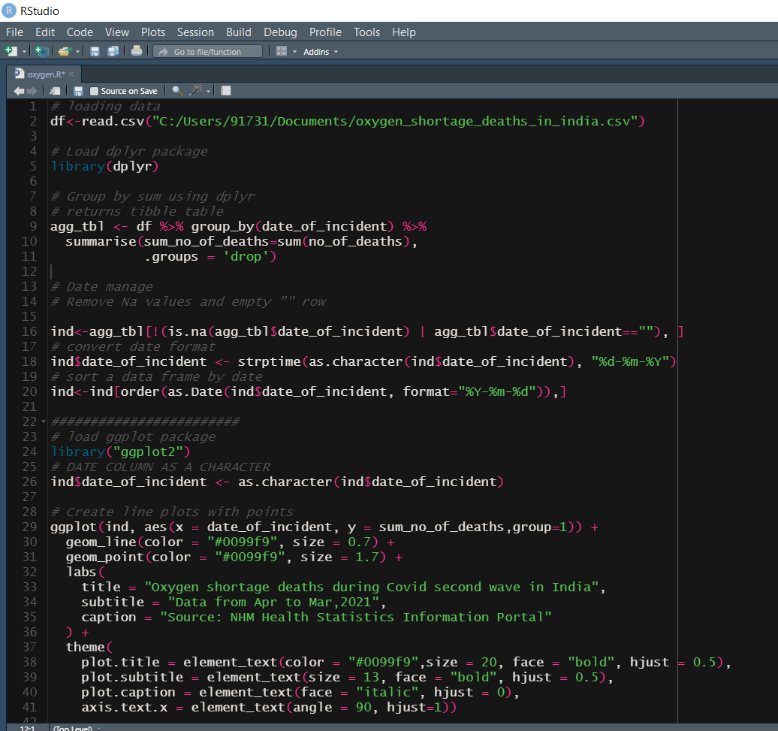

Data source link:

<https://raw.githubusercontent.com/datameet/covid19/master/data/oxygen_shortage_deaths_in_india.csv>

Comment: Hospitals across the country ran out of oxygen in April and May during a deadly second wave - there were daily reports of people dying from a lack of oxygen.

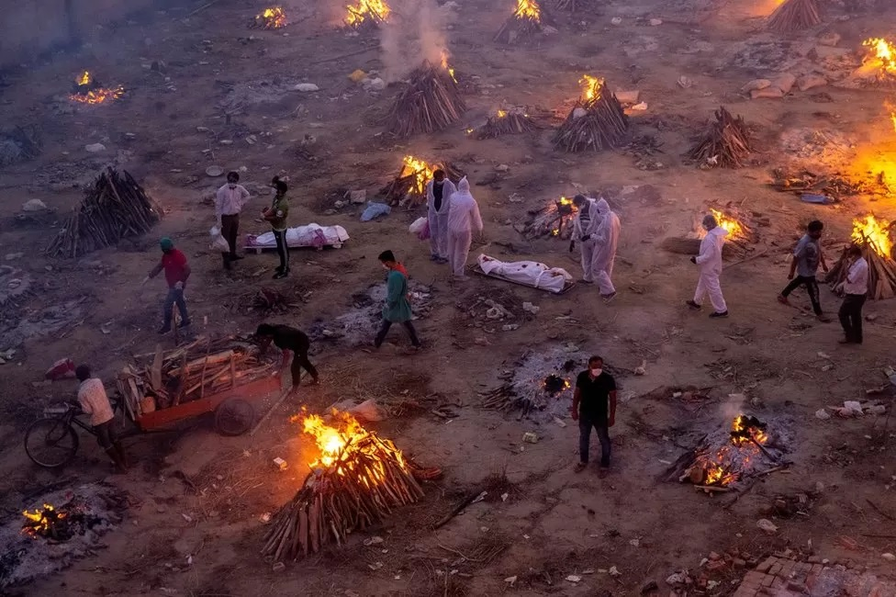

**Covid vaccine: India becomes second country to cross two billion Covid jabs**

**India has administered more than two billion Covid vaccination doses, becoming the second country to hit the milestone after China.**

"This has strengthened the global fight against Covid-19," Prime Minister Narendra Modi .India's Covid crisis hits Covax vaccine-sharing scheme

## 'A huge concern'

The SII was due to supply around half of the two billion vaccines for Covax this year but there were no shipments for March, April or May. The shortfall is expected to rise to 190 million doses by the end of June.

"Unfortunately, we're in a situation where we just don't know when the next set of doses will materialise," said Gian Gandhi, Unicef's Covax co-ordinator for supply.

The move came days after the country cut the gap between the second and third doses of the vaccine to six months from nine.

The Hindustan Times newspaper [reported](https://www.hindustantimes.com/india-news/92-of-population-late-for-covid-booster-dose-data-101657738256654.html) last week that 92% of Indians who were eligible for a booster dose haven't taken it yet.

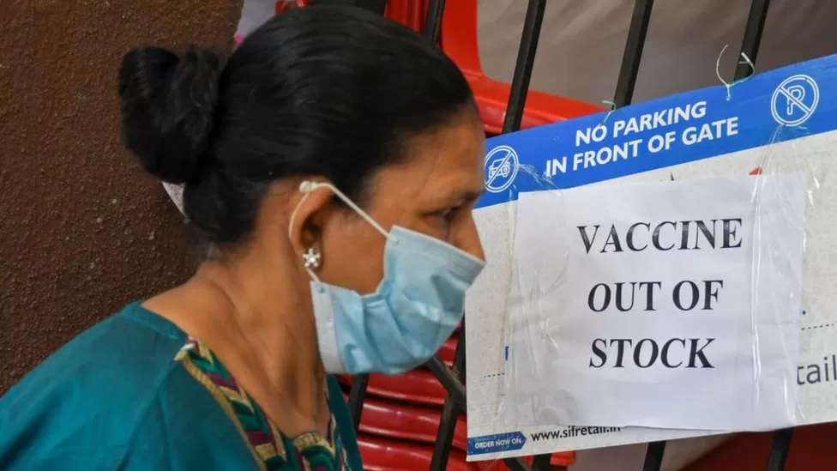

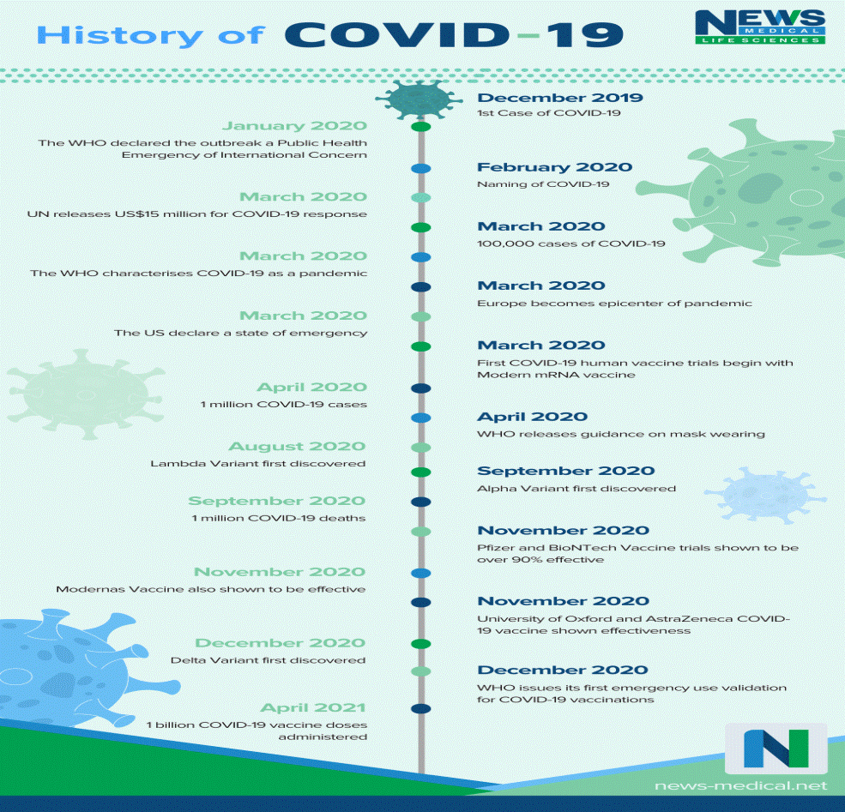

## Impact of COVID-19 pandemic on health system

**How has this impacted healthcare companies in India?**

While public policy measures have been implemented to contain the spread of COVID-19, the measures have resulted in significant operational disruption for many companies including those in the Indian healthcare industry. Staff quarantine, supply-chain failures, and sudden reductions in customer demand have generated serious complications for companies across a wider range of sectors than initially anticipated. For most, the revenue lost in this period represents a permanent loss and has put sudden, unanticipated pressure on working capital lines and liquidity.

Despite the current crisis being a healthcare issue, the private healthcare system in the country continues to reel under the negative impact of COVID-19. There has been a significant drop in both in-patient and out-patient footfall for private hospital chains—be it a single speciality, multi-speciality, tertiary-care hospitals or even diagnostics businesses, during this lockdown.

This sudden decline in business has had an immediate effect on hospitals’ ability to sustain fixed costs. The inability of new centres/hospitals to start generating cash, debt repayment obligations, decreased levels of medical tourism, and increased scheme revenues (which represents credit revenue) are some of the many factors impacting cash flow.  

**Impact on Health Services at facilities**

There has been a decline in Maternal and Child Health outcomes due to  
disruption in service delivery during the lockdown. Pregnancy registration, antenatal care check-ups, HBNC, and immunization significantly reduced during the lockdown period due to the suspension of outreach services as per government guidelines. However, post resun, the uptake increased with restart of outreach services.

.

**Mental Health impact on MHWs**Scoping review highlighted working during the pandemic has causing elevated levels of anxiety, burnout, depression, and stress among MHWs. The primary data echoed similar findings with elevated stress levels, anxiety, fear and mental fatigue Primary reasons gleaned from both primary and secondary data include long working hours, increased workload, and fear being infected and/or infecting family members. MHWs engaged in direct management of COVID-19 in ambulatory services, ICU, and isolation facilities have been most affected. Additionally, primary data highlighted dealing with difficult patients and family members, change in roles and responsibilities and resource constraints as reasons.

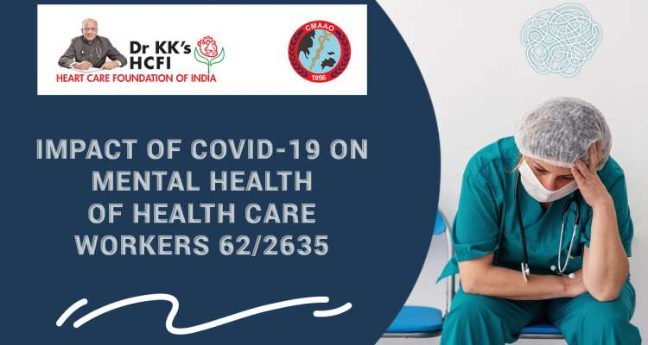   
**Impact on Physical health of MHWs**

Stress on the health system has severely impact MHWs physically. Working conditions of MHWs, demands of the job, and susceptibility to infection has resulted in insomnia, lethargy, loss of appetite etc. Psychological distress and physical stress have been positively associated. Primary data highlights increased instance of fatigue, exhaustion and burnout, stemming from increased workload and the use of PPE kits. PPE kit usage further led to suffocation, dehydration, and skin conditions

 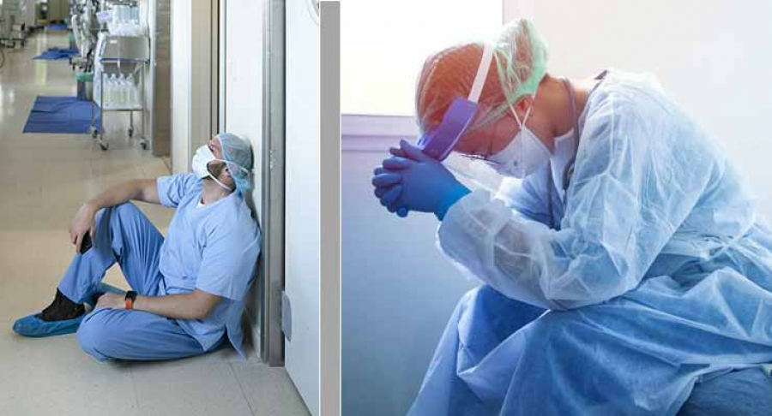

**Working Conditions of MHWs**

Facilities have established safety and infection prevention protocols as per  
guidelines and standard operating procedures recommended by national  
and sub-national authorities. Even so, qualitative data highlights resource crunches both in the form of human resources as well as supplies such as PPE kits and drugs.



### Conclusion

As we enter the COVID-19 recovery phase, it will be critical to reflect on the role of health systems - in fostering resilient societies. The global health crisis and the lockdown that followed have brought to the fore professions that have often been taken granted, renewing our awareness of their value to society. This helped restore a sense of esteem for those workers who have worked relentlessly during this time to keep economies afloat.

The frontline healthcare workers are at risk of physical and mental consequences directly as the result of providing care to patients with COVID-19. Even though there are few intervention studies, early data suggest implementation strategies to reduce the chances of infections, shorter shift lengths, and mechanisms for mental health support could reduce the morbidity and mortality amongst HCWs.

The most commonly reported adverse events with COVID-19 vaccines are expected vaccine side effects, such as headache, fatigue, muscle and joint pain, fever and chills and pain at the site of injection. The occurrence of these adverse events is consistent with what is already known about the vaccines from clinical trials.

The impact of COVID-19 pandemic and lockdown on health and healthcare was negative. The exaggeration of income inequality during lockdown can be expected to extend the negative impacts beyond the lockdown.

## References

* <https://www.thehindu.com/news/national/kerala/crippling-impact-of-pandemic-on-health-system/article38350258.ece>
* <https://www.bbc.com/news/world-asia-india-57911638>
* <https://www.news-medical.net/health/History-of-COVID-19.aspx>
* <https://www.jica.go.jp/india/english/office/others/c8h0vm0000fdjmnd-att/study_02.pdf>
* <https://www.thehindu.com/news/national/kerala/crippling-impact-of-pandemic-on-health-system/article38350258.ece>
* <https://www.bbc.com/news/av/business-55355587>